™



**089.21**

###### ТП.0006.300

###### PASSPORT

###### Operating Instructions

WATER HEATING BOILER

SOLID FUEL

(with steel heat exchanger)

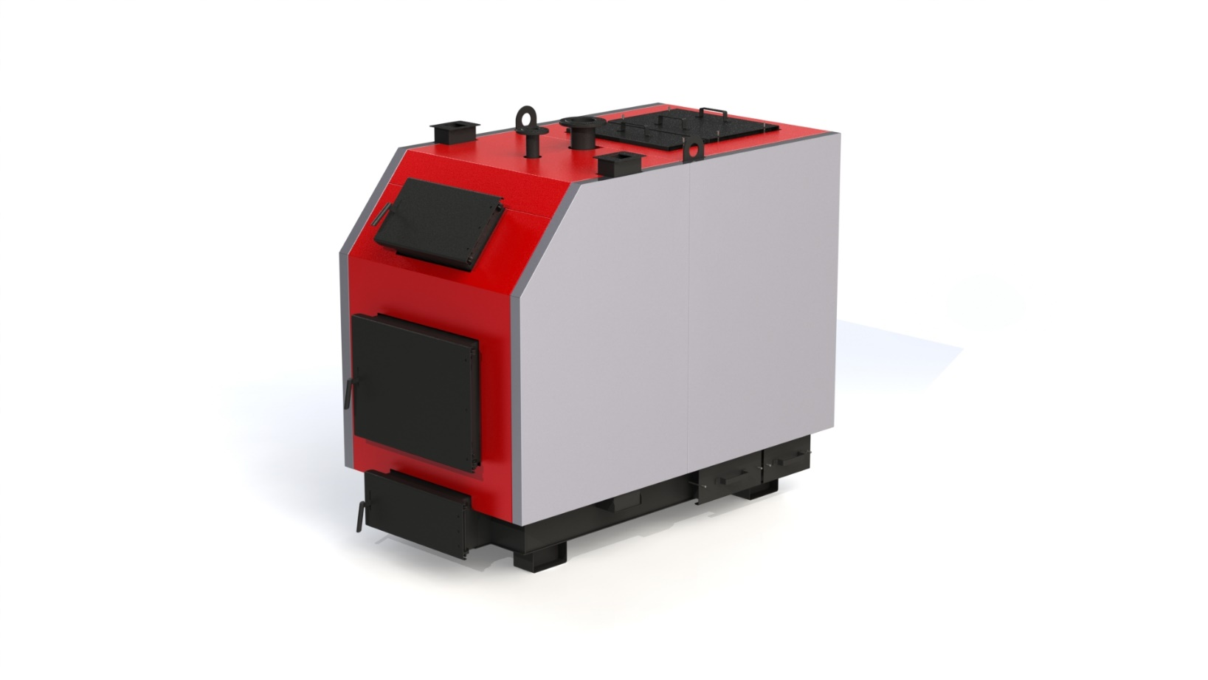

Products are certified in the UkrSepro certification system

№ U.TR.089. 0726.02-21 dated July 26, 2019.

LLC "VKP" Protek ", Kharkiv*Dear buyer!*

Thank you for choosing a PROTECH boiler. This documentation concerns the maintenance of low-power solid fuel boilers and contains all the necessary information and recommendations for their use.

Please read the following carefully before starting the boiler. Adherence to the instructions in this manual will protect you, protect you from improper operation and malfunctions.

The set of documents of the boiler equipped with electronics is accompanied by the instruction of the controller with which it is also necessary to get acquainted. Documentation and instructions must be kept in such a way that they can be used during operation of the equipment.

When purchasing a solid fuel boiler (hereinafter referred to as the boiler), check the completeness in accordance with section 2.6 and make sure that there is no visible mechanical damage.

The manufacturer is constantly working to improve the design of boilers and improve their quality, so there may be slight differences between your boiler and described in this manual.

*WARNING!*

When installing and operating the boiler, follow the rules of fire safety, monitor the technical condition of the boiler and the water heating system. Do not use or care for young children in the boiler.

**Content**

**1. Basic safety rules ............................................. ............................... 4**

**2. Purpose of the boiler ............................... ....................................... 5**

**3. Technical characteristics of boilers ........................... ................... 5**

**4. Delivery set .............................................. ....................................... 7**

**5. Description of the boiler design ................... ................................. 7**

**6. Fuel for the boiler ............................... ............................................ 9**

**7. Boiler installation ............................ ................................................ 10**

**8. Operation and maintenance of the boiler ............................ ......... 15**

**9. Possible malfunctions in the boiler ................................................. 18**

**10. Transportation and storage of boilers ............................... .......... 20**

**11. Warranty obligations ..................................................................... 20**

**1. BASIC SAFETY RULES**

Operation of boilers requires compliance with some basic safety rules, namely:

1.1 It is forbidden to operate the boiler without the use of a safety valve and (or) boiler safety group (for systems operating under pressure).

1.2 It is forbidden to operate boilers to persons under 18 years of age without adult supervision.

1.3 Do not touch the boiler with wet hands to avoid electric shock.

1.4 It is forbidden to carry out any work with the boiler or clean the boiler before it is disconnected from the power supply. To do this, move the main switch on the control unit and on the switchboard to the "OFF" position.

1.5 It is forbidden to make changes in the operation of safety and control devices without obtaining permission and recommendations from the manufacturer of this equipment.

1.6 It is forbidden to pull, tear, twist the electrical wires coming out of the boiler, even if the power supply is turned off.

1.7 It is forbidden to plug or reduce the size of ventilation openings in the room where the boiler is installed.

1.8 It is forbidden to expose the boiler to the effects of precipitation. The boiler is not designed for outdoor installation and does not have automatic antifreeze systems.

1.9 It is forbidden to store combustible materials and substances in the room where the boiler is installed.

***WARNING!***

Installation, maintenance and operation of boilers must be carried out in accordance with applicable regulations and rules, namely:

- NPAOP 0.00-1.81-18 "Rules of labor protection during operation of the equipment working under pressure".

- SNiP II-35-76 "Boiler installations";

- DBN B.2.5-67: 2013 "Heating, ventilation and air conditioning";

- DBN B.1.1-7-2002 "Fire safety of construction objects";

- NPAOP 40.1-1.21-98 "Rules for safe operation of consumer electrical installations".

DO NOT ALLOW CHILDREN AND STRANGERS TO THE BOILER!

**2. PURPOSE OF THE BOILER**

Boilers are intended for heating of household, industrial and other rooms in which the central heating system is equipped, for preparation and supply of heat for technological needs with use as fuel of firewood, wood waste, sawdust and peat briquettes, lump peat and coal. .

The design of boilers allows the most efficient use of heat released during the combustion of various types of low-calorie solid fuels, with the highest heat output of the boiler is achieved by burning coal.

It is possible to modify the boiler with automatic supply.

**3. TECHNICAL CHARACTERISTICS OF BOILERS**

The main technical characteristics of boilers are given in table 3.1

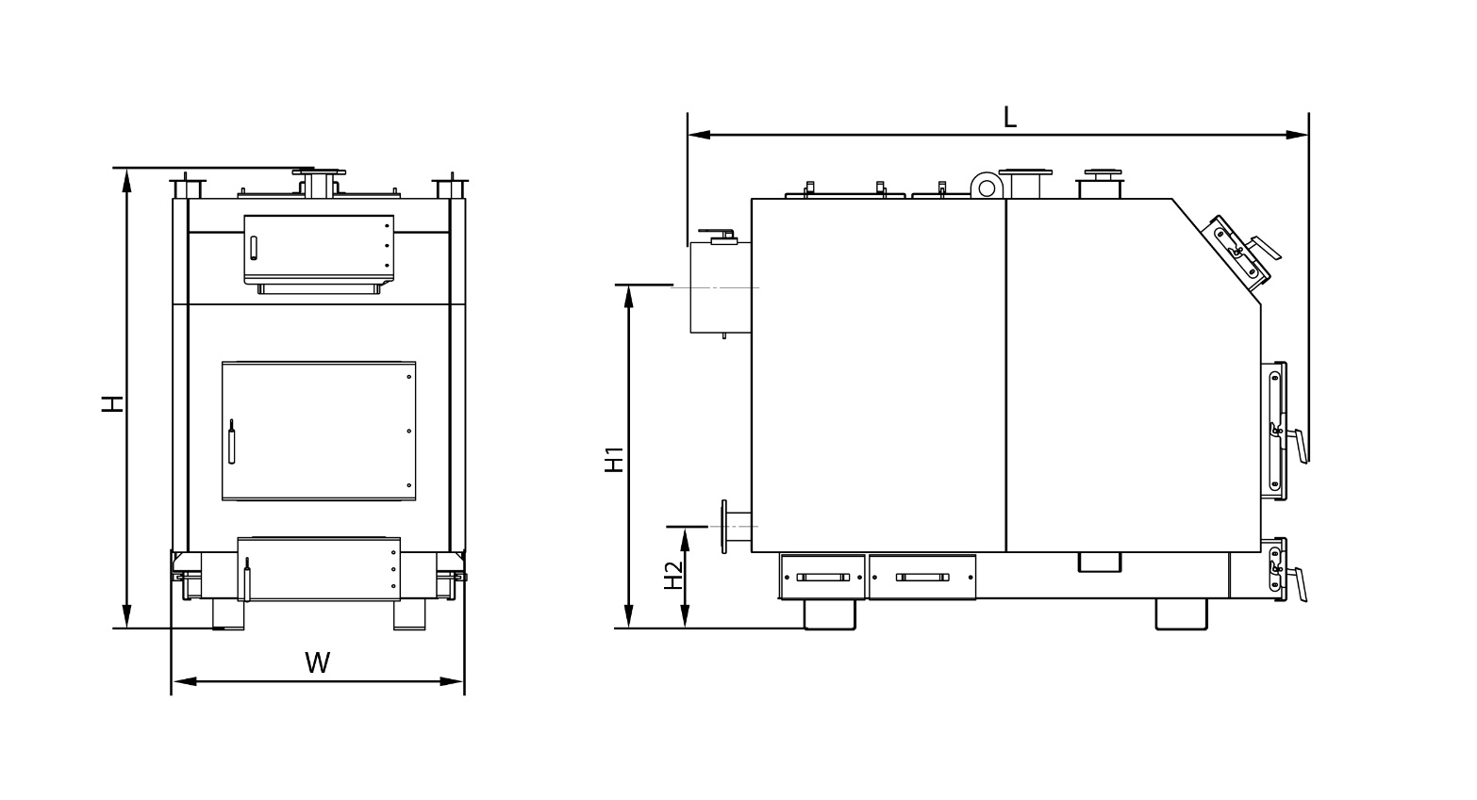

**Figure 3.1 - Designation of the dimensions of the boiler type TT-Smart MG**

Table 3.1 - The main technical characteristics of boilers series TT-Smart MG

|  |  |  |  |  |
| --- | --- | --- | --- | --- |
| Parameter | **Od. vim.** | **ТТ- 200** | **ТТ- 250** | **ТТ- 300** |
| Nominal power of the boiler | [kW] | 200 | 250 | 300 |
| Approximate heating area * | [m²] | 2000 | 2500 | 3000 |
| Fuel | - | Вугiлля, дрова, пелета, пелета соняшника | | |
| Efficiency (nominal), not less |  | 91 | | |
| Heat transfer area | [m²] | 19 | 27,5 | 31,5 |
| The volume of the hopper | [l] | 1000 | 1000 | 1000 |
| Boiler water tank | [l] | 550 | 755 | 850 |
| Boiler weight without water | [kg] | 1750 | 2300 | 2600 |
| Flue gas draft is required | [Pas] | 23-30 | | |
| The temperature of the flue gases at the outlet of the boiler | [° C] | 100-180 | | |
| The recommended minimum water temperature | [° C] | 55 | | |
| Maximum water temperature | [° C] | 90 | | |
| Nominal working water pressure | [bar] | 2 | | |
| Maximum working water pressure, no more | [bar] | 3 | | |
| Test water pressure, not less | [bar] | 4,5 | | |
| Electricity consumption, no more | [W] | 2х210 | 2х210 | 2х210 |
| The size of the loading door | [mm] | 600х500 | 600х500 | 600х500 |
| Combustion chamber height | [mm] | 1100 | 1100 | 1200 |
| The width of the combustion chamber | [mm] | 885 | 1060 | 1120 |
| Depth of combustion chamber | [mm] | 960 | 1260 | 1320 |
| The volume of the combustion chamber | [l] | 930 | 1470 | 1774 |
| Diameter of branch pipes of direct and return network water (Du) | [mm] | 100 | 100 | 100 |
| Diameter of branch pipes under the safety valve (Du) | [mm] | 50 | 50 | 50 |
| Connecting outer diameter of the chimney | [mm] | 348 | 398 | 448 |
| Recommended chimney parameters |  |  | | |
| cross-sectional area | [cm] | 910 | 1200 | 1520 |
| inner diameter | [mm] | 350 | 400 | 450 |
| height (minimum allowable) | [m] | 9 | 10 | 12 |
| Overall dimensions of a copper |  |  | | |
|  |  |  | | |
| H | [mm] | 1780 | 1780 | 1880 |
| H1 | [mm] | 1324 | 1324 | 1424 |
| H2 | [mm] | 400 | 400 | 400 |
| W | [mm] | 1134 | 1310 | 1366 |
| L | [mm] | 2380 | 2680 | 2740 |

* при потребi в теплi q - 100 Вт/м² для будiвлi, утепленої теплоiзоляцiєю товщиною 5 см;

**4. SUPPLY KIT**

Table 4.1 - Delivery set of KTP type boilers

|  |  |
| --- | --- |
| Name | quantity, items |
| Boiler assembly | 1 |
| Control automation unit | In order |
| Fan | In order |
| Boiler cleaning set | In order |
| Passport operation manual | 1 |
| Name |  |
|  |  |

**WARNING!!! A safety valve is not included.**

**WARNING!!! The automatic control unit, fan and safety valve are supplied in the manufacturer's packaging. The manufacturer specified in the product passport is responsible for warranty service of the above items.**

**5. DESCRIPTION OF BOILER STRUCTURE**

The appearance and main elements of the boiler are shown in Figure 5.1.

Structurally, the boiler is a prefabricated welded structure consisting of a housing (pos. 1) with a combustion chamber (furnace) (pos. 2). The convection part of the boiler consists of a four-way heat exchanger (pos. 3).

The boiler body is made in the form of a parallelepiped with double walls, which are separated by water partitions (pos. 17). Thermal insulation is fixed on the outer surface of the case under the decorative cladding (pos. 18).

Fuel for the combustion process is loaded on the grate (pos. 16) through the loading door (pos. 6). The grate is made of thick-walled seamless pipes through which water is constantly circulating from the water shell of the boiler, which makes it impossible to burn them. Combustion of fuel in the furnace occurs with the participation of air supplied through the air supply channel (pos. 19).

High-temperature combustion products, passing through the heat exchanger, transfer heat by convection of the coolant (water), which circulates in the water shell of the boiler.

|  |
| --- |
| 11 – Water drain fitting |
| 12 – The union under safety group |
| 13 – Chimney |
| 14 – Flue gas draft damper |
| 15 – Ashbin |
| 16 – Grid-iron lattice |
| 17 – Water shell |
| 18 – Thermal insulation of the case |
| 19 – Place for a fan |

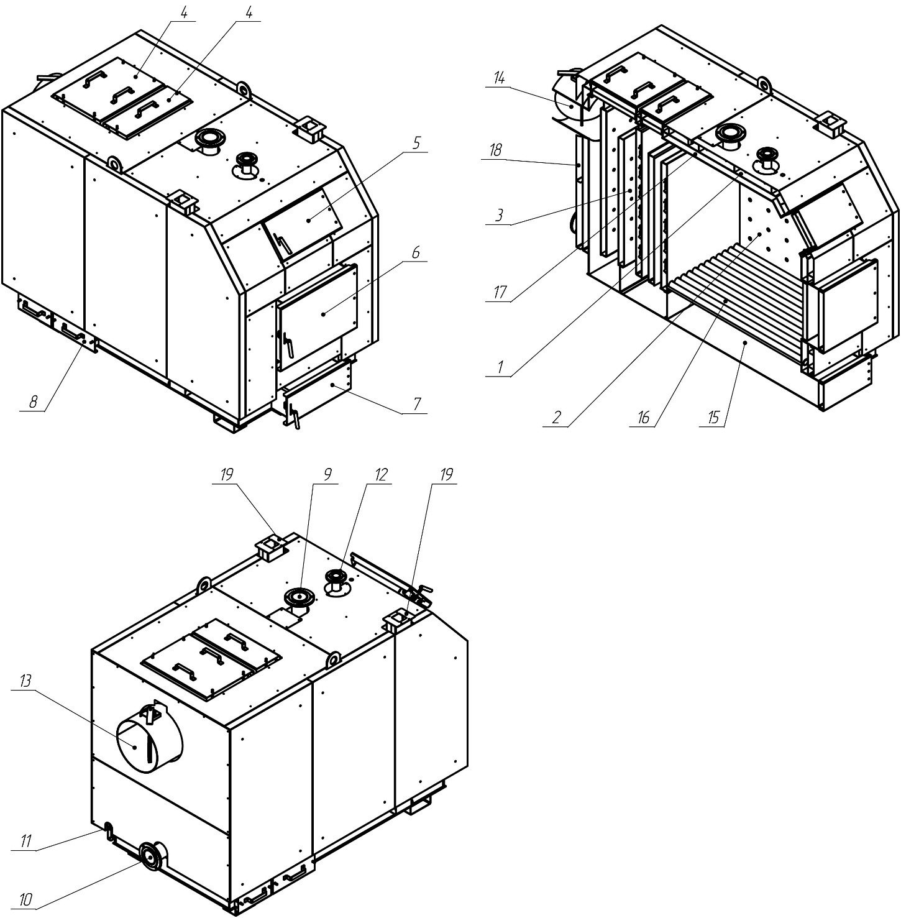

Figure 5.1 - Appearance and main elements of boilers type TT-Smart MG

|  |
| --- |
| 1 – Boiler housing |
| 2 – Combustion chamber (furnace) |
| 3 – Convection part (heat exchanger) |
| 4 – Convection door |
| 5 – The door is auditing |
| 6 – Load doors |
| 7 – Ashtray door |
| 8 – The door is side |
| 9 – Direct mains water pipe |
| 10 – The branch pipe of return network water |

Supply and removal of the heat carrier is carried out through branch pipes of return network water (pos. 10) and direct network water (pos. 9) accordingly.

Flue gases exit through the chimney (pos. 13), located in the rear of the boiler. The chimney is equipped with a built-in throttle valve of combustion products - gate valve (pos. 14). In case of too high draft in the chimney, the damper makes it possible to reduce it by partially covering the outlet.

The boiler firebox allows to burn such quantity of fuel which is necessary for maintenance of the temperature set by the user on the panel of the block of automatic equipment of management. The controller performs constant measurements of water temperature in the boiler and on the basis of these data controls the operation of the fan. The heating system can be connected to the circulation pump controller. A detailed description of the design and operation of the controller is given in the manual to it.

In the upper part of the boiler body there is a fitting for installing the boiler safety group (pos. 12).

On the side wall of the case in its lower part there is a fitting for draining water from the boiler (pos. 11).

On the front wall of the boiler in addition to the loading door are also located:

- inspection doors (pos. 5);

- loading doors (pos. 6);

- ashtray door (pos. 7).

**6. FUEL FOR THE BOILER**

The main fuel for the boiler is coal.

Also as fuel it is allowed to use:

- firewood, humidity not more than 25%. The length of the logs should be approximately 50 mm less than the depth of the furnace (see table 3.1);

- wooden briquettes with a diameter of 10-15 cm;

- as an impurity to the main fuel in a proportion of 50% it is possible to add wood waste with various qualitative parameters (concerning humidity) and various granulation (trimmings, shavings, chips, the wood waste formed at production of furniture, a parquet).

WARNING! The use of fuel other than the main one does not guarantee the normal operation of the boiler in accordance with the parameters listed in table 3.1, and may adversely affect the operation of the boiler or cause premature wear and failure of its components.

WARNING! The use of a fuel other than that specified is considered improper boiler operation. The manufacturer disclaims any liability for malfunctions caused by improper operation of the boiler.

**7. BOILER INSTALLATION**

Boiler installation must be performed in accordance with the boiler room design, performed and agreed in the prescribed manner, by qualified personnel with a certificate (a person with specialization, after completing a special course, who has the right to perform maintenance and repair work). It is the responsibility of the installer to familiarize himself in detail with the product, its operation and the mode of operation of the protective systems. Before connecting the boiler to the heating system, it is necessary to carefully read this Operating Manual.

After the installation of the boiler is completed, it is necessary to fill in and send to the manufacturer a control coupon for installation (see the appendix to the Passport). All entries in the coupon must be legible and accurate. Pencil entries are not allowed. In case of incorrect or incomplete filling of coupons, the boiler is not subject to warranty repair and maintenance.

**7.1 Requirements for the boiler room**

The boiler room in which the central heating boiler will be installed must meet the requirements:

- NPAOP 0.00-1.81-18 "Rules of labor protection during operation of the equipment working under pressure";

- DBN B.2.5-28-2006 "Natural and artificial lighting";

- SNiP II-35-76 "Boiler installations";

- DBN B.2.5-67: 2013 "Heating, ventilation and air conditioning";

- DBN B.1.1-7-2002 "Fire safety of construction objects";

- DBN B.2.2-9-99 "Public buildings and structures";

- SNiP 2.09.02-85 “Production buildings”.

The boiler room should be located, if possible, in a central place in relation to the heating rooms, and the boiler should be placed as close as possible to the chimney.

The entrance door to the boiler room must be made of non-combustible materials and open to the outside.

The boiler room must have supply ventilation in the form of a channel with a cross section of not less than 50% of the cross section of the chimney, but not less than 210 x 210 mm, with an air outlet in the rear of the boiler room. smoke, inability to reach higher temperatures).

The boiler room must have exhaust ventilation under the ceiling of the room with a cross section of not less than 25% of the cross section of the chimney, but not less than 140 x 140 mm (the purpose of exhaust ventilation is to remove harmful gases from the room).

**WARNING! It is forbidden to use mechanical exhaust ventilation. The boiler room must have a source of daylight and artificial lighting.**

Since the boiler fan absorbs combustion air from the room where it is installed, the air in the boiler room should not contain dust, aggressive or combustible materials (solvent vapors, paints, varnishes, etc.).

**7.2 Requirements for boiler installation**

It is recommended to install the boiler on a concrete elevation 20 mm high, but it is possible to install the boiler directly on a fire-resistant floor. The base on which the boiler is installed must be level, and the strength of the floor (floor) must be sufficient to withstand the weight of the boiler, taking into account the water in it. The boiler must be installed in such a way that it is possible to freely load fuel, as well as easily and safely maintain the furnace, ash pan, and clean the boiler. The distance of the boiler from the walls of the boiler room must be not less than 1 m.

All distances from the boiler body and its accessories to the walls of the room where it is installed must ensure easy and uninterrupted operation of boiler equipment (adjustment of boiler automation, the ability to conveniently load fuel, repair, etc.). It should be noted that when designing and installing the boiler and associated equipment, it is necessary to provide sufficient distance for easy opening of all boiler doors, cleaning of the combustion chamber and heat exchanger.

**7.3 Connecting the boiler to the chimney**

It is necessary to ensure compliance with the required value of the chimney draft (see table 3.1). The recommended values of the cross-sectional area of the chimney and approximate (minimum allowable) values of its height are given in table 3.1.

The permeability of the chimney must be checked and confirmed by a qualified chimney sweep at least once a year. To avoid the effect of back draft in the chimney, it is necessary to follow the recommendations for the minimum allowable departures of the chimneys, set out in the diagram:

It is recommended that the chimney starts from the floor level of the boiler room. At the bottom of the chimney it is necessary to provide a cleaning hatch with a tight lid.

The boiler chimney must be connected directly to the chimney by means of a flue made in the form of a steel pipe with a cross section not smaller than the cross section of the boiler chimney. The heat resistance of the flue must be at least 400 ° C. The total length of the horizontal sections of the flue should not exceed 3 m. The slope of the flue should be at least 0.01 towards the boiler. On pipes of the flue it is allowed to provide no more than 3 turns with a radius of curvature not less than diameter of a pipe.

The method of execution of the flue and connection of the boiler to it must meet the requirements of SNiP II-35-76 "Boiler installations".

The connection between the duct and the boiler chimney must be carefully sealed.

The boiler chimney is equipped with a built-in throttle valve of combustion products - a damper, with which you can adjust the amount of draft in the chimney.

If it is not possible to provide the recommended parameters of the chimney, and there are problems with draft in the chimney, which is manifested in improper operation of the boiler, it is recommended to use an exhaust fan or flue nozzle with built-in fan that supports and stabilizes draft.

**WARNING! Before starting the boiler it is necessary to heat the chimney**

**7.4 Connecting the boiler to the heating equipment**

**WARNING! The boiler is designed to work in heating systems with a water circuit, which operate at a pressure of not more than 0.25 MPa (2.5 kgf / cm2) and a coolant temperature of not more than 95 C.**

**WARNING! It is forbidden to operate the boiler without the use of a safety valve and (or) boiler safety group (for systems with forced circulation).**

The installed heating system before connecting the boiler must be thoroughly rinsed with running water to remove mechanical particles from the system, and also subjected to hydraulic tests at a pressure of at least 2.5 bar (0.25 MPa) with the expansion tank disconnected for 6-10 hours.

**WARNING! The general warranty on the boiler does not apply to functional malfunctions caused by mechanical impurities in the heating system. Filters in front of the boiler must be regularly checked and cleaned.**

There should be a minimum period of time between flushing the system, hydraulically testing it, and filling it with working coolant, as a system that is not filled with water is subject to intense corrosion. For the same reason it is necessary to empty the working heating system only in cases of extreme necessity, for the minimum possible intervals of time.

Boilers can operate in heating systems with both gravity (natural) and forced water circulation. See the manufacturer's website for recommended connection diagrams.

**7.5 Installation of the automatic control unit and the temperature sensor**

The automatic control unit must be mounted in a place where it will not heat up above a temperature of +45 ° C. It should not be placed above the elements of the boiler or boiler room that reach a high temperature. It is necessary to fasten the controller to the chosen basis for special assembly paws which are located on lateral walls of the case of the block of automatic equipment, metal screws.

The temperature sensor from the controller set must be fixed on an uninsulated section of the direct mains water pipe, using a cotter pin (bandage). After pre-tightening the bandage (the bandage can be wrapped around the pipe twice, or cut off the excess with metal scissors), insert the temperature sensor between the bandage and the pipe. Carefully clamp the bandage so that the temperature sensor does not move under the bandage. Too strong tightening can damage the measuring elements. Wrap the sensor with thermal insulation material.

Do not fill the temperature sensor with oil, water or other liquids. Conductive silicone pastes can be used to improve contact. Do not insert nails or other metal elements into the sensor

**7.6 Installing the fan**

The fan must be mounted on the flange with four screws.

The fan wire should be connected to the plug, then insert the plug into the appropriate socket in the controller.

**7.7 Connecting the circulation pump to the controller**

Connect the circulation pump to the controller in the following sequence:

- remove the cover from the pump electronics unit;

- to the zero clamp marked with the symbol "PE", connect the green-yellow wire - safety zero;

- brown and blue cores (N1, L1 230V) are connected to the clamping bar;

- Check that the connections are correct and tighten the cover.

**WARNING! When connecting the CO pump to the controller, pay attention to the maximum output capacity (see instructions to the controller, table Technical data). If the pump power is higher than specified in the instructions to the controller, the connection must be made via an additional relay (contactor with 220V coil).**

**7.8 Connecting the boiler to the wiring**

The boiler room must be equipped with 230V / 50Hz wiring in accordance with the requirements of current regulations. The wiring must be completed with an input socket with a protective contact. Damaged wiring can lead to the failure of the controller and be a source of threat to users of the boiler room. It is forbidden to use extension cords.

The connection of the controller and devices that work with it under a voltage of 230 V should be performed only by a person who has the necessary qualifications (professional electrician) in compliance with the requirements of DNAOP 0.00-1.21-98 "Rules for safe operation of electrical installations of consumers."

**WARNING! Before connecting the pump and fan, remove the plug from the mains socket, which supplies power to the controller!**

It is necessary that the live wires that supply the devices are far from the elements of the boiler, which are heated during operation (doors, chimney).

**7.9 Filling with water**

Water for filling the boiler and heating system according to its indicators must meet the requirements of NPAOP 0.00-1.81-18 "Rules of labor protection during operation of pressure equipment".

The boiler and the entire heating system must be filled with water through the water drain fitting. Filling should be done slowly to ensure that air is removed from the system.

**Water quality requirements**

Water quality has a great influence on the duration and efficiency of heating equipment. Water with non-compliant parameters causes surface corrosion of the heating equipment and fossilization of the internal heating surfaces. This can damage or even destroy the boiler.

The warranty does not cover damage caused by corrosion and scale. The following are the requirements for the quality of the boiler water imposed by the manufacturer on the user, compliance with which is mandatory for any warranty claims. Water for filling the boiler and heating system must comply with the rules and regulations of the country in which the boiler is installed.Котлова вода повинна мати наступні параметри:

PH level> 8.5

Total stiffness <20 ° W

The content of free oxygen <0.05 mg / liter

Chloride content <60 mg / l

The water purification technology used to fill the heating system must meet the above water quality requirements. The use of any antifreeze additives is permitted after prior consultation with the boiler manufacturer. Failure to comply with the requirements for the quality of boiler water can lead to damage to the components of the heating system and the boiler, for which the manufacturer is not responsible.

**WARNING! It is forbidden to add cold water to the equipment during the boiler operation, as this may damage it.**

**8. BOILER OPERATION AND MAINTENANCE**

**8.1 Ignition of the boiler**

The first start-up of the boiler is carried out by service personnel, who after the completion of commissioning works put the appropriate mark in the control coupon on commissioning.

Before putting the boiler into operation it is necessary:

- read the operation manual. Boiler operation should be carried out in strict accordance with this manual;

- ventilate the room for 15 minutes;

- check for draft in the chimney.

8.1.1. Load fuel into the boiler furnace. To do this, open the loading door and place a layer of fuel on the grate. After that, reload through the door pos. 5 (see Description of the boiler design) to the limits of the lower edge of the hole. Place incendiary material on the stacked layer of fuel: paper, chips, firewood (in the listed sequence). Fully open the damper on the boiler.

8.1.2. Switch on the power supply of the control unit with the power switch "0-1". Set the value of the "Fan performance" parameter according to the type of fuel used. Use the "+" and "-" buttons to set the desired temperature level.

8.1.3. Ignite the paper enclosed in the furnace as incendiary material When the top layer of fuel in the furnace is evenly ignited, it is necessary to close the loading door, and turn on the fan with the "Start / Stop" button. The fan will run until the water in the boiler reaches the temperature set on the controller. During ignition, as well as during the whole combustion process, the current water temperature value is shown on the display.

***Read more about debugging and operation of the controller in the instructions to it.*8.2 Boiler operation**

Power is regulated by a fan that provides air to the furnace under the grate (adjustable automatically), and, in case of too high draft, the damper located in the chimney of the boiler.

**WARNING! Operation of the boiler at a return water temperature less than 55ºC leads to condensation of water vapor contained in the flue gases. The formed condensate settles on the walls of the boiler, which leads to active corrosion of the metal and a significant drop in efficiency. Prolonged use of the boiler at lower temperatures can reduce the service life of the boiler.**

**At the initial stage of boiler operation, the formation of condensate in small quantities is possible.**

**The boiler damaged as a result of low-temperature corrosion is not subject to warranty repair.**

If during the operation of the boiler there is an interruption in the power supply or blockage of the circulating pump, it is necessary to immediately stop the supply of fuel to the boiler and close the damper on the boron boiler. Insufficient heat transfer from the boiler to the radiators can cause water to boil in the boiler. To avoid such a situation, it is recommended to introduce into the heating system an additional heat accumulator (boiler, heat accumulator), capable of accepting the theoretical minimum thermal power of the boiler due to gravitational circulation.

After the fuel in the furnace runs out, as evidenced by the flashing of the diode "Work" on the panel of the automation unit, you must turn off the fan by pressing the "Start / Stop" button. Then open the door and clean the grate with a scraper (if necessary). Then open the loading door and load the required amount of fuel. Repeat the ignition procedure (see section 8.1).

**WARNING! It is allowed to reload fuel into the furnace when no more than one third of the height of the initial fuel tab burns out.**

**WARNING! Opening the loading door, during the operation of the boiler, should be carried out in the following sequence:**

**1. Turn off the fan.**

**2. Wait for the fan to stop completely.**

**3. Slowly open the loading door only 10-20 mm, wait 10-15 seconds to equalize the pressure difference in the combustion chamber and the room.**

**4. Open the loading door.**

**5. Carry out the necessary work (fuel level control, refueling).**

**6. Close the door.**

To ensure the tightness of the door, it is necessary once a season to lubricate the door sealing cords with graphite grease (or any other machine oil) or sealing mastic.

**8.3 Boiler maintenance**

In order to save fuel and obtain the declared power and efficiency of the boiler, it is necessary to keep the combustion chamber and convection channels clean. Failure to comply with the following recommendations can not only cause high fuel consumption, but also complicate the circulation of combustion products in the boiler, which, in turn, can cause "smoking" of the boiler. Systematic maintenance of the boiler extends its service life.

**WARNING! All maintenance work on the boiler must be carried out in protective gloves with the obligatory observance of safety requirements.**

It is recommended to clean the convection ducts from ash and sludge every 3-7 days (depending on the fuel used). Convection ducts must be cleaned when the boiler is not working.

Removal of ash from the boiler must be performed as it is filled, but at least once every 3-5 days. To remove the ash, the ash must be removed with a poker and removed. The combustion chamber must be cleaned of tar and deposits with a scraper as it gets dirty, but at least once a month.

The grate must be cleaned as it is clogged with soot and incomplete fuel combustion products.

An important condition for the proper functioning of the boiler is cleaning the chimney. The permeability of the chimney must be checked and confirmed by a qualified chimney sweep at least once a year.

**8.4 Termination of boiler operation**

If it is necessary to repair the boiler during the heating season, if there is no risk of water freezing in the heating system, water from the entire system can not be drained. At the same time it is necessary to disconnect a copper from heating system by means of shut-off valves and to drain water from it.

Frequent water changes in the heating circuit should be avoided.

**WARNING! Do not extinguish fuel with water in the boiler room!**

**8.5 Conditions for safe operation**

To ensure safe operating conditions of the boiler, the following rules must be observed:

- keep the boiler and related equipment in proper technical condition, in particular, take care of the tightness of the heating system equipment and the tightness of the door closing;

- keep order in the boiler room and do not accumulate there any items not related to the maintenance of the boiler;

- in the winter it is impossible to make breaks in heating to prevent freezing of water in the equipment or its part;

- it is forbidden to ignite the boiler with such means as gasoline, kerosene, solvents;

- it is forbidden to add cold water to a working or heated boiler or heating system;

- all actions related to the maintenance of the boiler must be carried out in protective gloves;

- all boiler faults must be rectified immediately.

The boiler must be systematically cleaned of soot and resinous substances - because the sediment on the walls of convection channels disrupts the heat transfer process, which in turn reduces the efficiency of the boiler and increases fuel consumption.

**8.6 Disposal of the boiler**

To dispose of the boiler, worn-out equipment (boiler) must be handed over to a special disposal organization in accordance with current regulations.

**9. POSSIBLE FAULTS IN THE BOILER OPERATION**

In case of unreasonable call of the service department, the transport and working expenses of the service workers are paid by the client. Therefore, before calling the service, get acquainted with the typical problems in the operation of the boiler and ways to solve them.

The list of possible malfunctions of the boiler, their causes and methods of elimination are given in table 9.1

|  |  |  |
| --- | --- | --- |
| Symptom | Reason | Method of elimination |
| Smokes outside | Insufficient draft of the chimney | Eliminate leaks in the chimney or boiler door |
| Insufficient chimney height | Raise the chimney to a height of at least 1.5 m above the ridge |
| The section is too narrow | Adjust the chimney damper, reduce the fan power |
| chimney | Use a fan that increases the draft of the chimney |
| Atmospheric pressure is too low | Clear channels |
| Low boiler efficiency | Chimney pollution | Change the fuel to high-calorie |
| channels | Ensure normal air flow through the window |
| Low calorie burning | or ventilation duct |
| fuel | Reset the parameters according to the Instructions from |
| Plaque of resin and moisture inside the boiler | Weak air flow to | operation or replace with a new one - serviceable |
| boiler rooms | Clean ducts and other heat exchange surfaces |
| (symptoms similar to the course) | Breakdown of the blower fan or the controller | Use fuel according to instructions from |
|  | Contamination of the inner surface of the combustion chamber and convection channels | service |
| Leakage  Excessive draft of the chimney | The use of wood as the main fuel for heating | Operate the boiler for |
| The boiler maintains a low temperature | temperatures of at least 57 ° C |
| Excessive fuel consumption | estimated by the manufacturer | Repair in service |
|  |  |  |

**10. TRANSPORTATION AND STORAGE OF BOILERS**

1. Shipment of boilers is carried out in the packaging of the manufacturer in accordance with the technical documentation.

2. Transportation should be carried out only in the manufacturer's packaging. It is strictly forbidden to move with support behind the boiler casing.

3. Storage must be carried out in the packaging of the manufacturer in a vertical position in one row in height.

4. Storage of the boiler should be carried out indoors with natural ventilation with fluctuations in ambient temperature from plus 40ºC (upper value) to minus 50 ° C (lower value) and relative humidity of 75% at plus 15 ° C (group of conditions 2 according to GOST 15150-69).

5. Connecting threads are preserved for 1 year.

**11. WARRANTY OBLIGATIONS**

1. The manufacturer guarantees the proper operation of the boiler for 40 months from the date of sale and through the retail network, and for non-market consumption - from the date of receipt by the consumer. When exporting boilers for export, the warranty period is calculated from the moment of crossing the state border of Ukraine.

2. The manufacturer is not responsible for breakdowns caused by improper use, transportation and storage of the boiler by the owner.

3. After receiving the boiler by the buyer, the manufacturer does not accept claims for incompleteness and mechanical damage to products.

4. In the event of failure of any unit or boiler as a whole due to the fault of the manufacturer during the warranty period, the company repairs or replaces the defective unit or boiler free of charge.

5. Claims with the addition of a issued warranty card are sent to the manufacturer.

6. At the request of the enterprise, the owner also sends a defective unit or boiler.

7. In case of change of a design and completion of the device by the owner without the coordination with the enterprise-manufacturer, claims concerning quality are not accepted.

8. In case of failure of any boiler unit during the warranty period due to the fault of the owner or failure of any unit after the warranty period, the manufacturer may replace or send a suitable unit for a fee.

9. Claims for unsatisfactory operation of the boiler are not accepted if the calculation, installation and selection of the boiler were carried out without the participation of a certified installation organization.

**Certificate of acceptance and sale**

Boiler water-heating solid propellant TT _____ with ______________,

factory № ___________ meets the technical conditions for the product DSTU 3075-95 (GOST 9817-95) and is recognized as suitable for operation.

Date of issue "_____" __________________ 20___

Stamp VTK (receiver mark):

Date of sale "_____" __________________ 20___ р.

Manufacturer: LLC "VKP" Protek ", Ukraine, Kharkiv,

street Velyka Panasivska (Kotlova), 183 USREOU code 39272432

Довідково-інформаційна служба: тел. (057) 782 2 792